OAuth Migration Process – Intelligent Logistics

Effective August 8th, UPS has changed the way 3rd Parties integrate with UPS. Intelligent Logistics must adhere to UPS’s requirements which means how UPS integration works with Intelligent Logistics tracking information is changing. Our Customer Success Team is available to help you navigate the new process. However, we are not allowed to set up your UPS.com users or administer them any longer.
Note Intelligent Logistics will continue to operate after the August 8th deadline and data will continue to flow into Intelligent Logistics after August 8th. However, it is important to begin the migration process ASAP to adhere to UPS’s requirements.
This will not change the way end users log into Intelligent Logistics, only how Intelligent Logistics authenticates to access your UPS tracking data. Thus, there will be no impact on users of Intelligent Logistics. Users will continue to enjoy the exact same Intelligent Logistics experience before and after the migration.
Per UPS:
At UPS, we strive to provide the best service and security for our customers. To give you control over which of your UPS shipping accounts are accessible to an application, we have implemented a new authentication and authorization technology, called OAuth, for applications to access your accounts.
Migration Steps
The migration process should be performed by one Intelligent Logistics Administrator in your company. Again, this process will not be performed by all Intelligent Logistics users. Only one Intelligent Logistics Administrator must complete a four-step process:
- Establish a UPS.com user account. It is highly recommended that you sign up note with an email distribution list or a shared mailbox instead of your own company email (il_support@company.com is better than john.doe@company.com). By using this approach, we avoid the need to do the entire process again if the person associated to the email address leaves the organization. You cannot use a UPS.com account that is used for CampusShip. If you have already created a UPS.com user account as part of the migration of a different UPS solution/integration then that new UPS.com user account can be used, and you won’t need to establish a new UPS.com user account. You can skip step #3 if the already created a UPS.com user account and had UPS accounts associated to it.
- Provide your UPS.com account username and the email address to the Intelligent Logistics Customer Success Team. You can do so by emailing your Customer Success Team Member. If you don’t know who that resource is, then please email your UPS.com account username and email address to il-customersuccess@contax.com. Do not provide your UPS.com password in the any communication with the Intelligent Logistics Team.
- Establish Account Associations: Customers can establish account associations directly on UPS.com using recent Invoice Method or a PIN Method sent to the account contact email UPS has on file. If you have 100+ accounts to associate, or questions about the account association process in general, please contact your UPS Account Executive for assistance.
- Authorize the UPS integration in Intelligent Logistics.
  - The steps to Authorize your UPS integration in Intelligent Logistics are listed below. Upon completion of these steps please reach out to the Intelligent Logistics Customer Success team so they can validate the steps were performed correctly.

Authorize the UPS integration in Intelligent Logistics
- Your Company Administrator will log into Intelligent Logistics and select the “Manage Integrations” application in the Management section. If you cannot find the application, then please reach out to the Intelligent Logistics Customer Success Team.
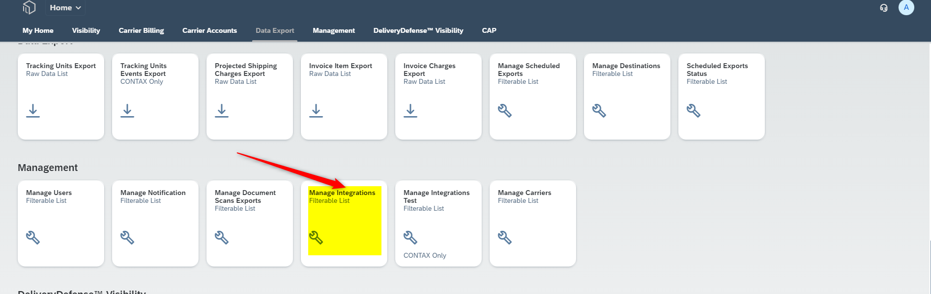

- Click on “Create”
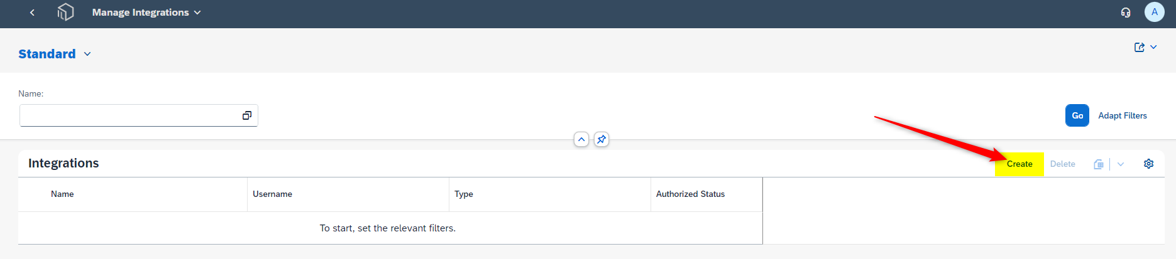

- Enter in the “Name” field (ex. *CustomerName IL Integration*) and select “UPS with Quantum View Data from the dropdown in the “Type” field. Note the “Name” can be any description you want.
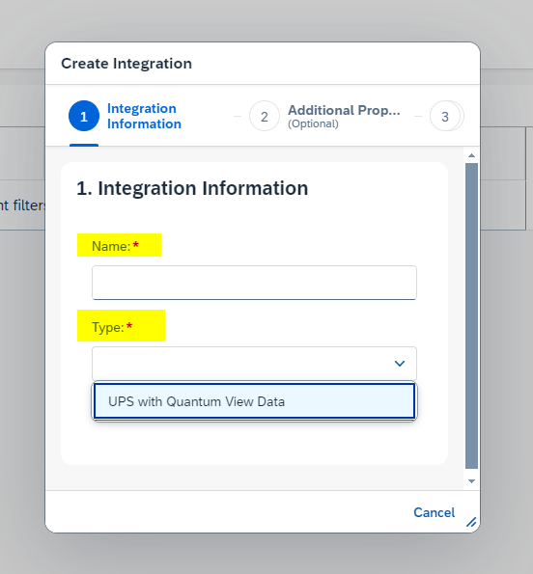

- After completing those fields, select “Step 2”.
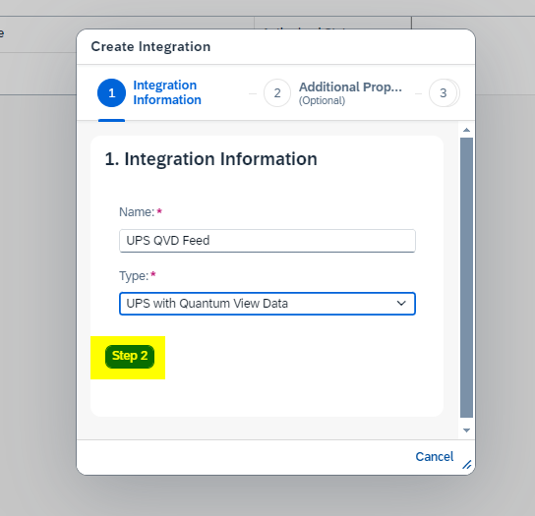

- Enter the QVD Subscription Names that are provided to you by your Customer Success resource. It is important that what you enter in the Subscription fields exactly matches what your Customer Success resource provides you. Note you might not use all three subscriptions so only enter those provided to you. If you have any questions, then please reach out to your Customer Success Team Member or email il-customersuccess@contax.com.
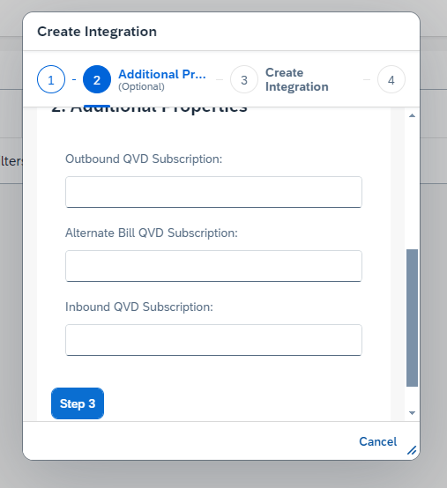

- After entering the QVD Subscriptions, select “Step 3”.
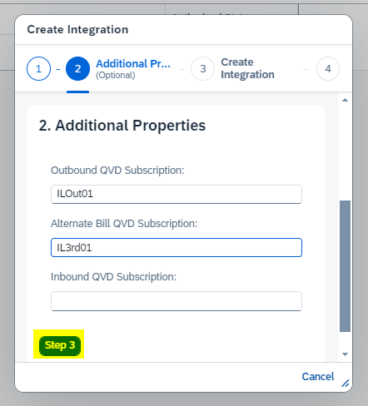

- Select “Create” and then select Step 4
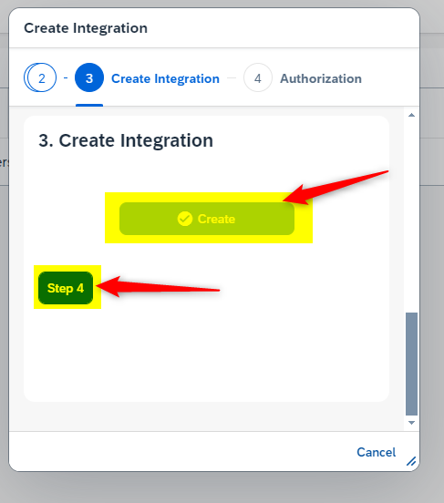

- Select “Authorize”
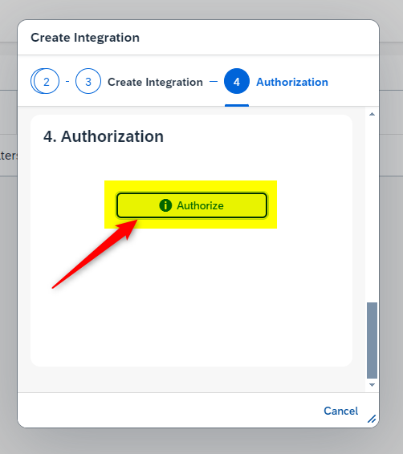

- You will be prompted in the popup window to enter your UPS.com login credentials, completing the integration. These are the same credentials of the UPS.com user account you created in Step #1. Start by entering the UPS.com Username and check the box authorizing the agreement. Then click the “Continue” button. Note you might need to scroll down in the popup window to find the “Continue” button.
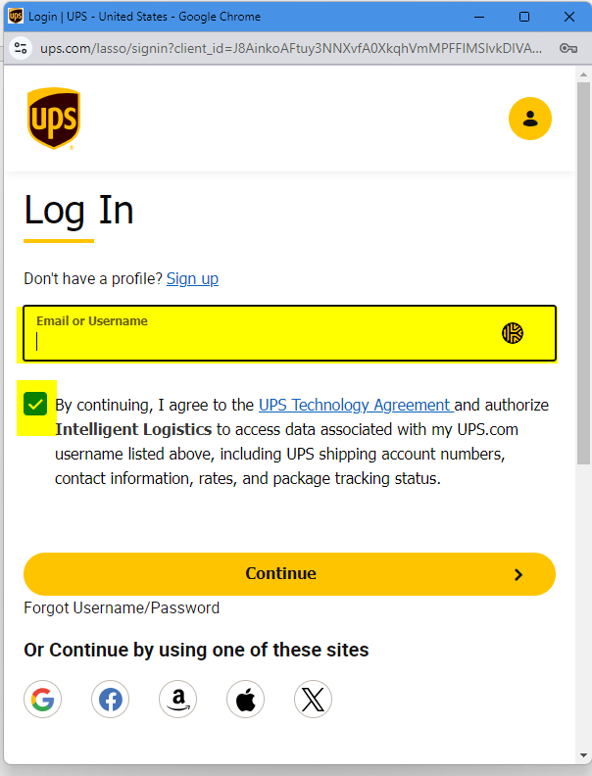

- You will be then prompted for your password. Enter your password and click the “Logon” button.
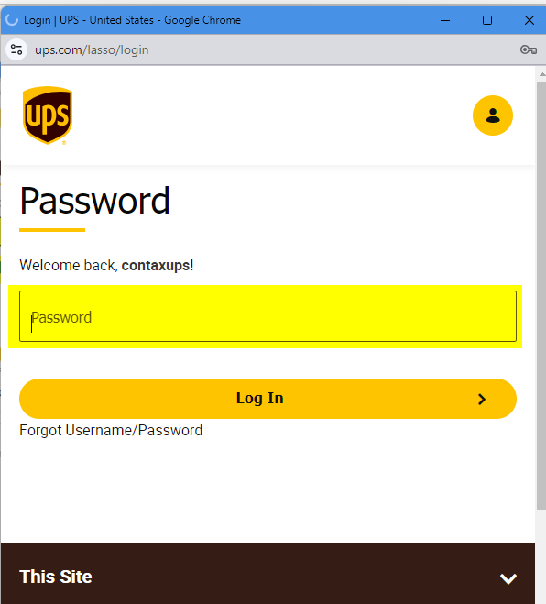

- Upon success you will see the following text in the popup window. You can now safely close the popup window.
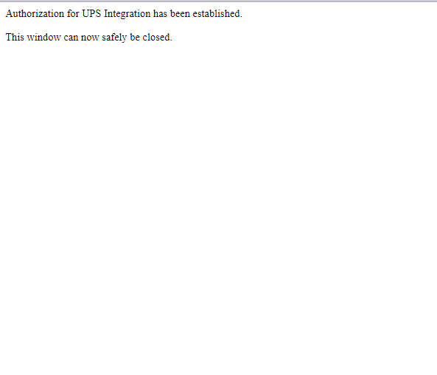
- Click the “Complete and Close” button to finish the process.
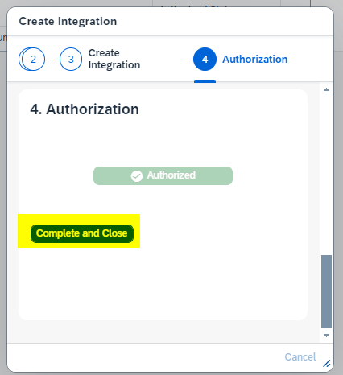

Your Integration will now be listed in the Integrations List. The “Authorized Status” should be set to Authorized. If it is not set to Authorized, then please reach out to your Customer Success Team Member for assistance. Reminder once you complete these steps, please communicate with your Customer Success Team Member so they can validate the Integration is set up correctly.

